Capacity Planning for Vincent

ITEM FILE

Work Centres

Create IBS test

Work Centres

WO_BULLETIN_BOR

Calendar IDs

Work with reports/jobs - MFG orders

Work Centre/Workload Results

The propose of the document is to record the IBS settings that are currently set and then what we need to change to use the Inventory Control (IC) with Supply Plan (SP) and Workload (W).

IBS Inventory Control can be used in combination with the following applications for

advanced planning and forecasting:

• IBS Sales and Operation Plan

This application is used to view the demand and supply situation on an

accumulated level. Sales and Operation Planning (SOP) is an overall planning

tool, which will allow a big picture of demand and supply figures overtime on

an aggregated level, e.g. item group, item family or item sector.

• IBS Demand Plan

This application is used to work with sales forecasts. It allows you to quickly

update, delegate and review the forecast figures. Each demand plan is

connected to a hierarchy that specifies the sales related keys for which

information should be retrieved.User’s Guide

• IBS Supply Plan

The supply plan, which is based on the IC forecast, is used to define how much

and when replenishment of items should be made. The calculated supply plan

value can be used as input to the MRP and for purchase suggestions.

Of three I believe we will be using SP because the documentation for W mentions this plan.

# 

# 

# ITEM FILE

It appears everything starts at the ITEM FILE entry. It is this entry that you define the units of measure that are needed to create the item. The inventory that this item is going to come from and it’s dimensions. The supplier and the warehouse that creates the item.

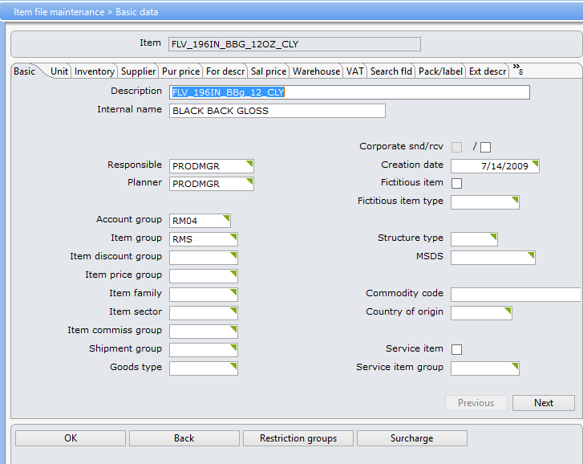

The following shows the current settings for the Purchase Type for bulletin 12 oz material in the VPI warehouse.

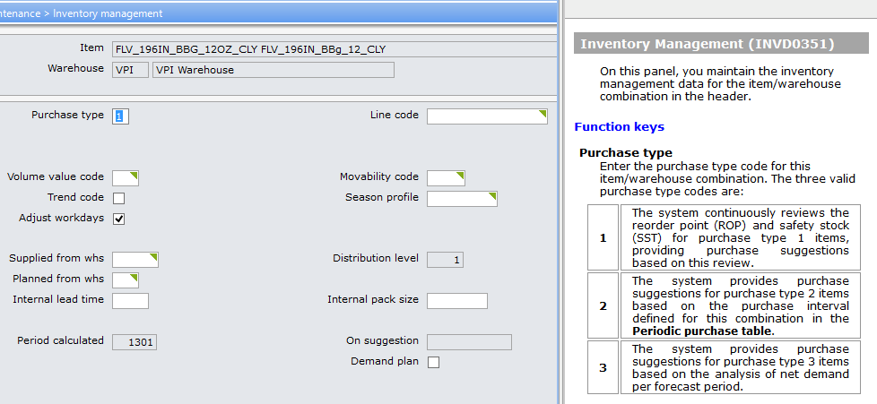

We may have to set those items for the planning to either 2 or 3. So far for our needs we are OK.

# Work Centres

Work centres are the departments that will handle the creation of the product. You define the work centres as follows.

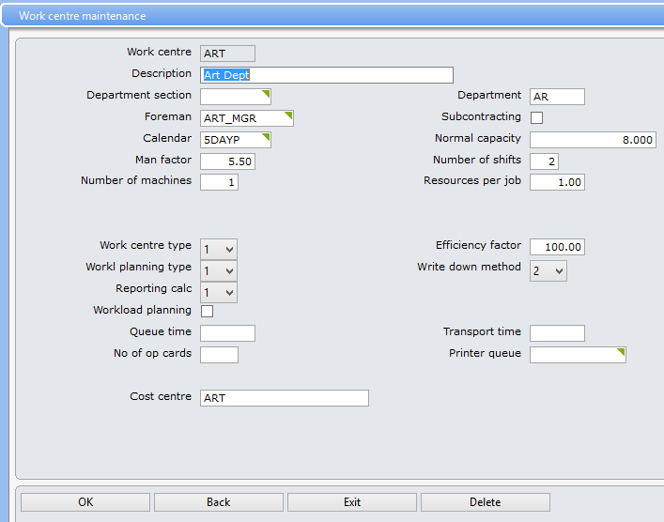

To use workload you must set “Workload planning” to yes/checked. The settings “Write down method” and “Workl planning type” are used in determining when workload is removed.

# Create IBS test

In this section we will document what settings we are changing in order to test the workflow feature and if it worked.

## Work Centres

The documentation states that the setting on each entry should be checked for the Workload. I am going to copy each entry I find in the BOR entry for bulletins.

### WO_BULLETIN_BOR

WO_BULLETIN_BOR has the following work centres. It looks like I will only have to deal with three of them.

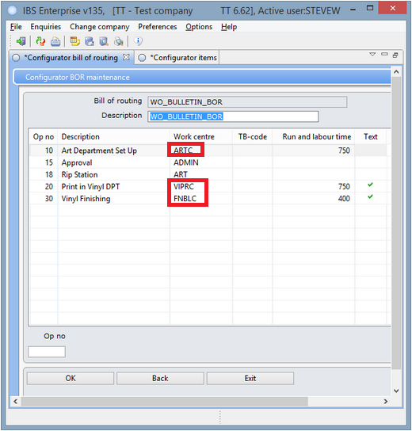

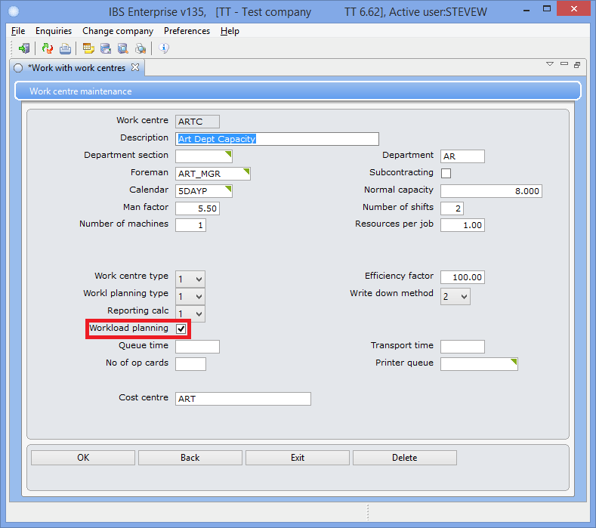

So I copied the ART work centre and created ARTC with the workload planning set. I will do this for VIPRX and FNBL. I will add these new centres to the BOR then I will create several orders and see if the voodoo works.

## Calendar IDs

This section is where you plan the calendar days and capacity.

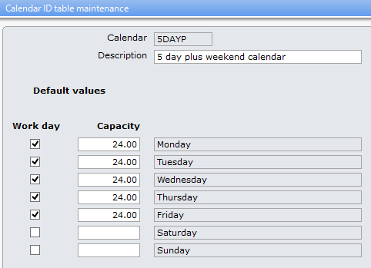 The original calendar.

## 

The new calendar.

## 

## Work with reports/jobs - MFG orders

This section is where the workload is initially created.

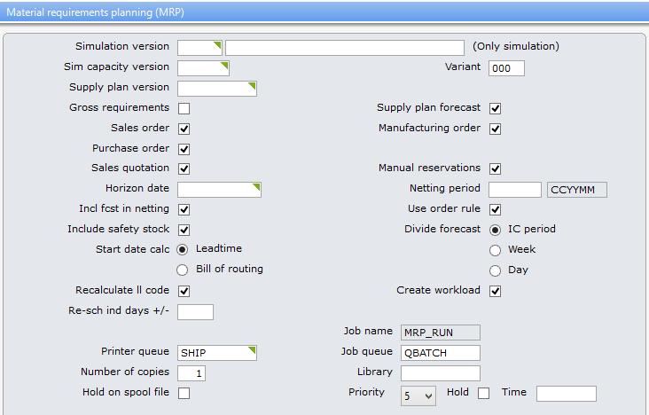

The following documentation I found in the Help text.

Start date calc(page field)

The code indicates if the requirement start date will be calculated using the item's lead time or using the total needed operation time. Valid codes are:

|  |  |
| --- | --- |
| **1** | **Lead time** |
| **2** | **Bill of routing** |

### 

## Work Centre/Workload Results

Well I created eight orders with none of the dates changing so WWAB.

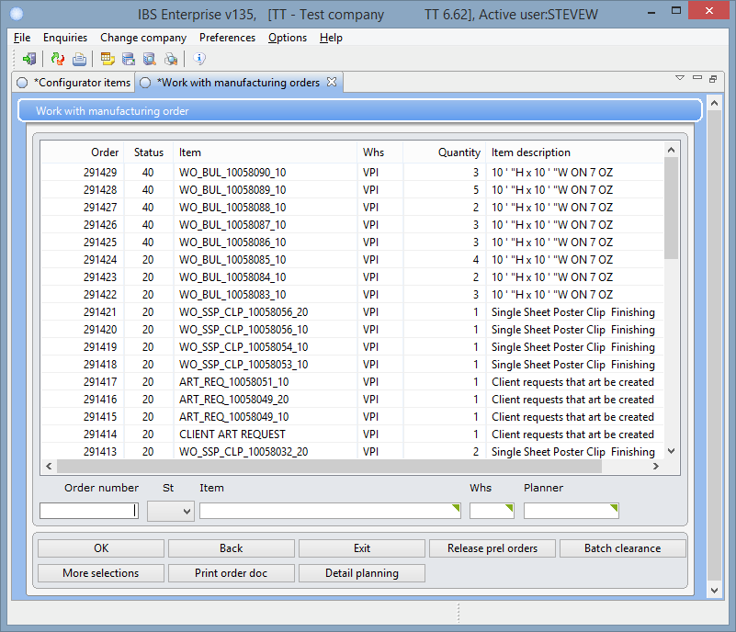

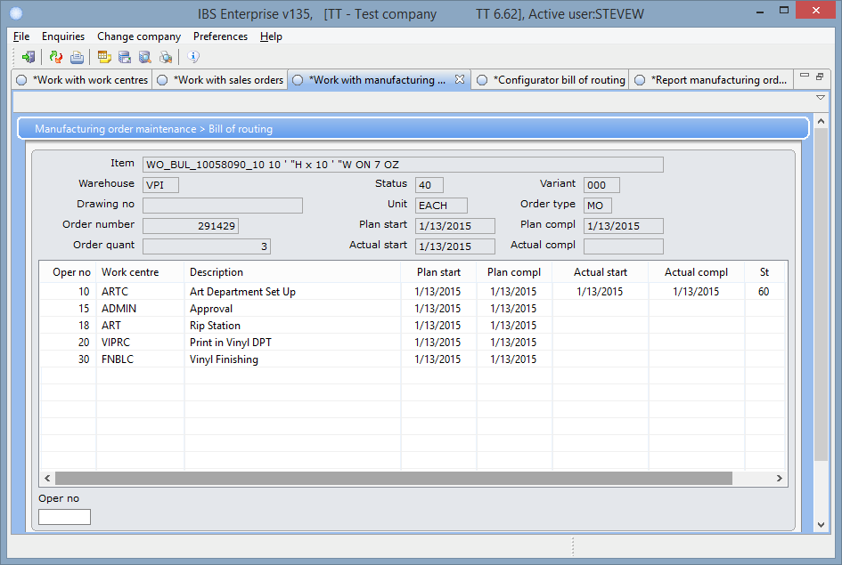

I used the Report MF Order to set the operations on all of them, place another order it did nothing. So I change all of the operations nothing.

I noticed this comment in the documentation for the BOR

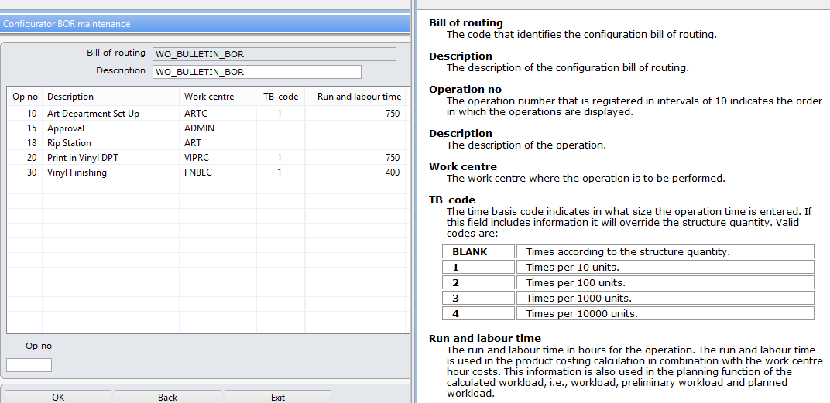

The TB-code was not set in the original BOR which it reads to me that it will use quantity. I changed my operations to 1. Nothing has changed, WWAB.

In the documentation for the BOR there is the following comment for setting the BOR.

*Refer to the* ***Online help*** *for details about the remaining fields.*

***Note*** *In order to calculate a time, enter both the time in hours and the*

*corresponding formula in fields* ***Run & labour, Set-up int, Set-up ext and***

***Machine***

So I tried to set just the “Run & labour” fields with success. I don’t know if all of the fields are to be set for this feature to work correctly.

You can get to the workload enquiry through the Enquiries menu.

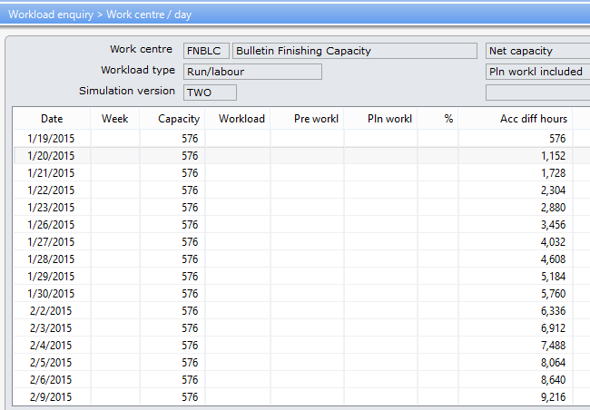

Something is not set correctly when it comes to capacity. Everything is showing up on the 19th.

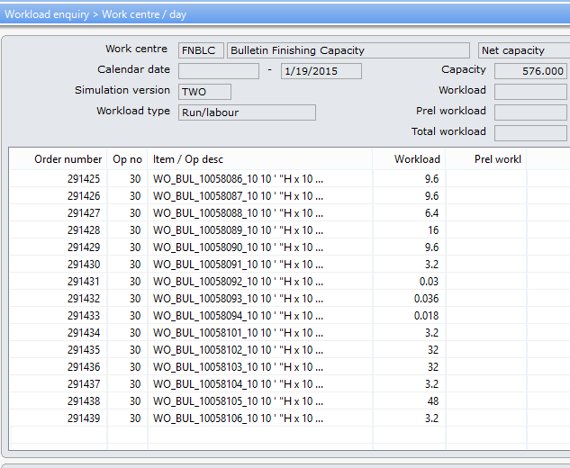

Note: I was able to get the the workload to show up on the enquiry screen by setting the “Write down method” to 2 for WorkCentre ARTC.

Update: 1/22/2015 TJ and I got together and worked through the settings. He found that the capacity values needed to be corrected. Once everything was adjusted the correct capacity calculated. Now on to how to schedule the results in MRP.

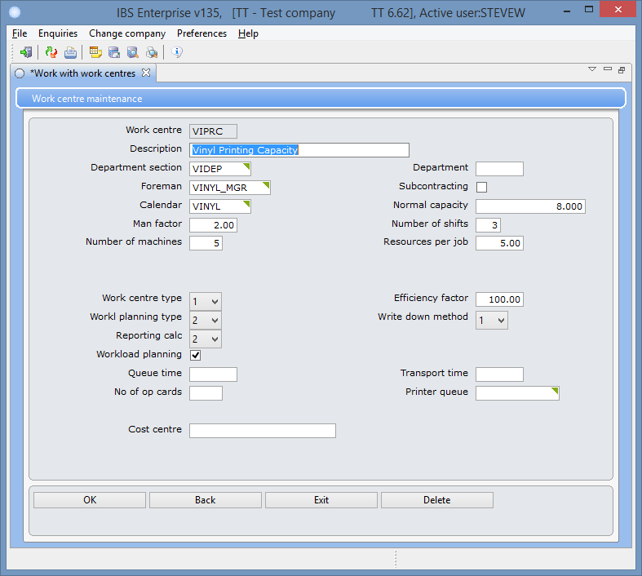

We changed the settings on this work centre.

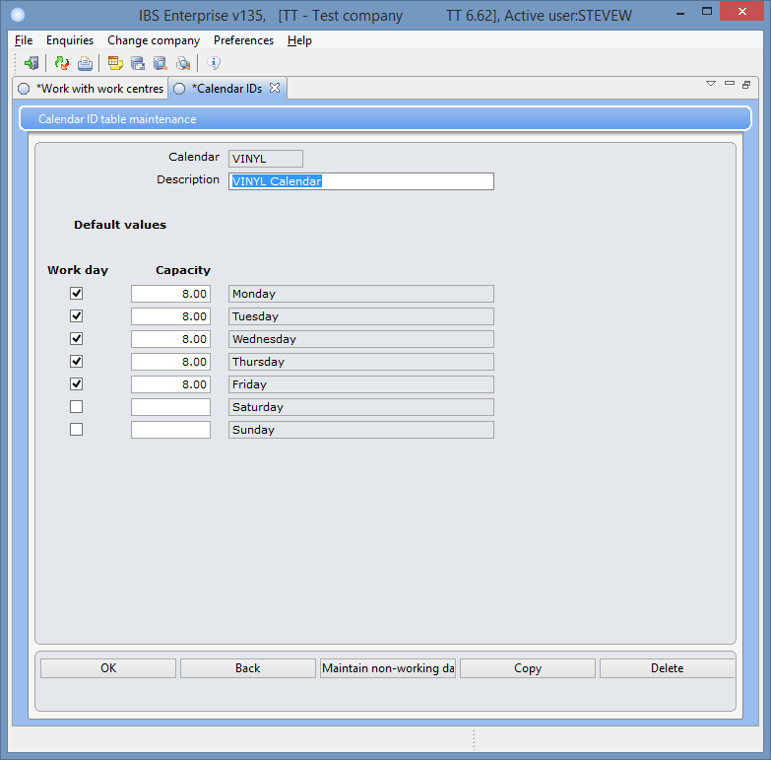

We used this calendar for the work centre to get the capacity to calculate correctly.

# Manufacturing

So what IBS tools do we use to take the mfg orders created from the steps above and schedule them?

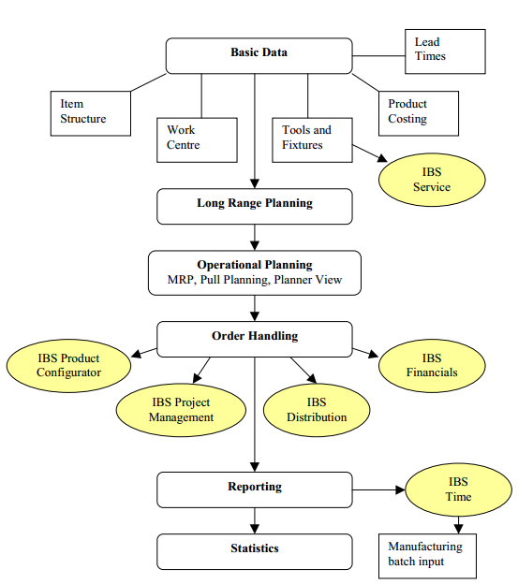

I believe we need either Operational Planning or Order Handling. It could be that we can use both.

## 

## 

## Operational Planning

## 

## 

## Order Handling